Bullita cave - Poster
Chris Bradley
National University Caving Club & Canberra Speleological Society

Where is it:
Bullita cave is located in Limestone Gorge of the Gregory River National Park, about 50 km south of Timber Creek in the Northern Territory.

When did the survey start:
John Dunkley had communication with a friend who worked in the NT who said that the area looked promising. The ranger of the time, Keith Claymore had done a lot of research there and had found several caves and developed Australia's first 4wd track in a national park. This goes from Bullita homestead to Humbert River and has been featured in some 4wd magazines and newspapers.

In 1991, a group from CSS went on a trip to Gregory NP and found several caves. It wasn't until 1993 that the "Backyard" was found, but we now know that one of the caves we have since connected into was found in 1991. TESS's (Top End Speleo Society) cave was also found around that time.

Participants:
Since 1992, we have had joint trips to Gregory NP with many other clubs. Clubs included have been:
NUCC, VSA, Mole Creek, ISS, CEGSA, WASG, TESS, and we have had international visitors as well. As there has been so much work to do, the joint trips have been invaluable. We have tried to organise the trip so that TESS members can join us, and so that the mapping efforts could be combined. This has been quite successful and given our groups an opportunity to help out with each others caves.

Surveying & Mapping:
In 1991 and 1992, we mapped relatively small caves, so when the backyard was found in 1993, it was quite a surprise. In 1994, more of the backyard was surveyed, and in 1995 we linked into a cave that TESS had previously found. From there it was just a matter of working east and joining up with several other caves that had been mapped in previous years.

Bullita cave was 73 km long as of Jan 2001 (it is now over 87 km as of July 2002). Each year various connections are deliberately left as a carrot for the members joining on the trip in the next year.

Don Glasco produced the original maps which were very impressive. We input the data into Compass to process loop closures. There are now over 7000 points of data and each year the data files get bigger. Then the data was exported using ArcTools into ArcView to produce the maps. Since then, Bob Kershaw, Tony Veness, Veronica Schumann and myself have produced maps for use in the field for each successive trip.

Tony produced some fantastic A0 colour plots of the cave with digital terrain, drainage and even aerial photography superimposed (See Plate 1.). We were fortunate with the aerial photographs, which while quite old, were of the same scale as the topographic maps. We also have newer aerial photographs of the area, but they are at a different scale, and are not as detailed as the earlier ones, so were not as useful for field work, or for scanning for the mapping process.

The Future:
In 2000, we mapped another significant cave, "SOCOG's", which was not too far from the southern extent of Bullita. If this could be connected to Bullita, then the length of the cave could exceed 80 km, but the connections were likely to be tight (This connection was in fact made in 2001).

One of the biggest challenges, however, is not surveying, but is the mapping. Many hundreds of hours have been devoted to inputting data into Compass, printing the line drawings and then drawing up the maps. This is a continuous job, and only increases each year as more cave is discovered.

Access to Gregory National Park for mapping of caves is becoming more strict as the National Parks are producing their management plans for the area. The condition of our permits mean that we are required to supply them with our data for use with their own electronic maps.

There are still several more, smaller caves that can be connected to the main Bullita cave, plus there are many sections deep within the main cave that have not been surveyed because it can take so long to navigate to them. There are still many years work left in the area, and while it is open to debate, I would estimate that keen cavers could look at getting a total length of well over 100 km.

12/July/2002
email: chris.bradley@netspeed.com.au

Plate 1. Colour plot of the cave with digital terrain, drainage and aerial photography superimposed is shown in the CD-ROM version of these Proceedings

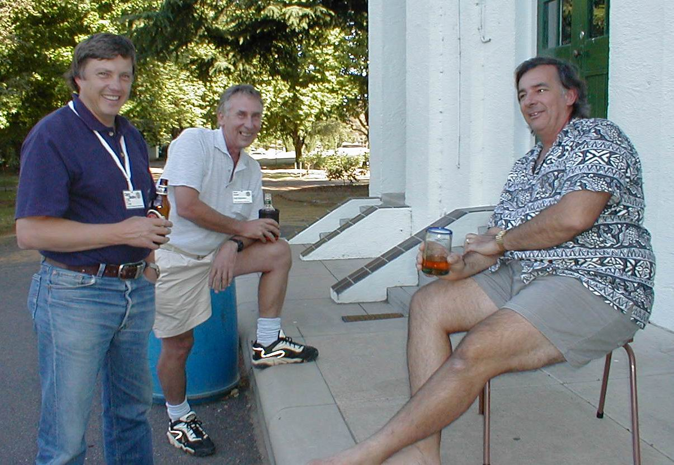
Chris Bradley, Noel Sands and Peter Berrill in Bathurst Arthur Clarke
FLOOD EFFECTS IN MCKEOWNS VALLEY AND MAMMOTH CAVE, JENOLAN CAVES, NSW.

C. Henry Shannon, 319 Brisbane Street, West Launceston Tas 7250.

Introduction.

The author has been putting his archive of caving reports on to the hard disk of a new computer with a view to making the information more generally accessible. In the process all the flow measurement data from the Jenolan hydrology project has been put together, and enough new concepts have emerged to make this paper on the subject worth the effort. The hydrology project flourished from 1960 onwards, tapering off after peaking in 1972. But since the author is now ageing and living in Tasmania it really needs some dedicated successors to train themselves in the velocity head measurement technique, and vow themselves the quest of collecting the necessary better and missing data. The heroes of my vision will take on Northern Mammoth in full flood conditions, laugh as they descend the Ninety Foot pitch, splutter their way through the no longer dry “Dry Siphon” roof sniff, grunt their way through the North Tunnel crawlway and arrive gasping at Great North Cavern. And there they will collect the measurements considered “too hard to get” in 1972.

The original hydrology work was oriented around water tracing and became a “learning experience” in which less was achieved by the work with fluorescein than would be possible now with more developed technique. But the flow measurement data taken at the time, and not then regarded as very important got figures when critical and rather rare flow situations were observable. These now appear to hold most of the answers that the fluorescein tests were supposed to find. A core concept developed during the work is that of the limited capacity choke. In essence a conduit with a limited capacity choke accepts increasing flow up to a critical point, then spills any more into an alternative route, like a partly blocked drain. In this paper the author attempts to place true capacity values on all the limited capacity chokes that affect Mammoth Cave and to check the total flow of a notional standard Mammoth Cave Flood against a notional standard flow for the Jenolan Underground River efflux.

A fix on the capacity of the Jenolan Underground River

On 17th January 1963 the creek ran through the Devils Coach House for about a day following a day of heavy rain, reaching a peak flow of 200 l/sec. The Jenolan Underground River built up in flow after this and reached a flow of about 1000 l/sec (estimated) with some time lag as measured at the efflux into Blue Lake. This estimate is based on a mix of measurement and extrapolations, and is less reliable than I would like. At this time the weir at the efflux was set up so that a substantial proportion of the flow went over the top and could be measured, and it moved out into the lake as a separate stream alongside the portion going through a hole in the weir. This relationship meant that a figure could be obtained indirectly for the total. At still higher stages previously known figures for the flow under the weir gave a basis to work an estimate from when the flow over the weir interfered with the relationship. It was a far from ideal set up to work with but changes since then have made it impossible. Later and after dark that same day other figures were collected at the bridge in Imperial Cave, then well under water with the flood still rising. This allowed an estimate of 40 cusecs, say 1150 litres/sec. It is a bad measuring point having a drowned bridge in it, but this value would better approximate the “full capacity” of the underground system. It is compatible with the earlier figure on the day, and these data are all there is in the author’s records for the situation where there is flow through the Devils Coach House. Yet the average of 1075 litres/sec has a certain value (see below).

Of course “full capacity” is a concept that wobbles. Considerably higher floods in the Imperial Cave have occurred; up to the thirty second step in the floods of 1954 (F. Harman pers. Comm.) What the conditions of the day probably revealed is the situation in which unexceptional levels of base flow; (that is, the slowly diminishing drainage from groundwater storage) was supplemented suddenly by unexceptional inputs from all the watersinks along McKeowns Creek; that is, the typical situation.

The flood response to an advance to Wiburds Bluff.

In December 1960 an advance of McKeowns Creek to the vicinity of Wiburds Bluff produced something like a doubling of the flow in Lower Level River (160 to 370 litres/sec), with little effect on Central Level River (a rise of 4’ 1.2m in Central Lake). A measurement of 1.5 cusecs = 42 litres/second was taken first crossing appearance of the river. The more usual figure taken for the Central Level River around this time was 0.5 cusecs = 14 litres/second), a figure the author got repeatedly during the early 60’s but at the second crossing or Ohmeneez measuring point.

The interpretations that follow from this behaviour are that the rivers are separate. Lower Level River has its main source up the valley from the vicinity of Wiburds Bluff and that Central Level River has a different and more local source. Prior to these observations it was possible to argue that Central River floods were evened out to produce the flow of Lower River. A clue that was missed at the time concerns chemistry. Central River is a borderline case for carbonate saturation. Portions of its bed upstream from first crossing have stones coated with travertine, and calcite flottante can appear on the surface of Central Lake; its downstream continuation. Lower River is always lime dissolving.

The drying of Central River at second crossing.

The flow measurements considered standard for Central River at this period were taken at the second crossing. As the 60’s and 70’s progressed generally drier conditions prevailed, leading to lower values for the stream at 3 l/sec or even 1.5 l/sec and scepticism with regard to earlier measurements. Fewer measurements were taken at the first crossing and the hints of a larger flow were attributed to poor measurement technique. Eventually the Central River dried up at the second crossing on at least two occasions while continuing to run at first crossing. A hidden and more permanent tributary or anabranch is needed to account for this behaviour.

The flood response to flow reaching Serpentine Cave.

A series of three trips in February-March 1972 produced good data set for resolving the relationship of the water sinking outside Serpentine Cave to the response in Mammoth Cave. The point to be made (see table below) is that there is a very close match indeed between what goes down here and what appears in the Northern River passages. Other points are that water comes out of the Infinite Crawl before the Serpentine Cave itself starts to operate, and that although the Infinite Crawl gets most of the water, some goes to second crossing and boosts the flow going to the Bypass. I would guess that this is what comes through the ceiling of Great North Cavern. Serpentine Cave is fairly well over to the west of the limestone belt but the Woolly Rhinoceros Cave must lie even further to the west.

The flow measurements also revealed the notional unseen permanent tributary of Central River more clearly. It is effectively an underground river below you even when you are underground. The author has taken to calling it the Sarasvati after the Hindu sacred river believed to join the Ganges from underground at Varanasi. It is interesting that early 60’s flow measurements show the same difference of 1 cusec extra for the First Crossing site detected in the 1972 data.

At the second crossing measuring point an example of a limited capacity choke can be seen in operation. Normally the Central River goes down a floor hole but once the critical capacity is exceeded, any additional flow is spills into the normally dry Bypass, and the route through the floor hole operates as a constant volume conduit.

Flow in the Northwest Passage through to the Overflow in full flood is very confusing with streams entering and leaving the accessible passage at several points. Both the Hidden Branch from second crossing (Ohmeneez) and the Sarasvati apparently join and cross underneath the Northwest Passage to get to the points near the Overflow Lake where all bar about 7 litres/sec of what got to first crossing on 26-2-72 was visible.

Table of Flow data: Serpentine Submergence point and Mammoth Cave
Location | Date and amount sinking (in l/sec) shown by colour:  29-2-72, 26-2-72, 12-3-72.
 | Measurement point for flow in McKeowns Creek which sinks in the stream bed in the vicinity of Serpentine Cave.
Serpentine area, surface & S. Cave |  | U/s cnr. M.Ck. | Serp. Cave
Serpentine area, surface & S. Cave |  | 8.5 l/sec | No flow ?
Serpentine area, surface & S. Cave |  | 20 l/sec | trickles
 |  | 100 l/sec | 28 l/sec
Ohmeneez | Measurement points/inferred flows taken beyond the Dry Siphon in the Northern River Passages of Mammoth Cave
 | Hidden branch | Bypass stream | Infinite Crawl | “Sarasvati”
 | 25.5 | 2.8 | 11.5 | 28.5 (indirect)
 | 25.5 | 7 | 14 | 28.5 (indirect)
 | 25.5 | 20 | 85 | 28.5 (indirect)
 | Measurement/inferred flow of Central River at First Crossing, below the junction of all the separate streams above
1st crossing | Below 90 foot
 | 68
 | 78
 | 159 (indirect)

The Hidden branch is determined from the difference between the Ohmeneez measuring point and the flow in the Bypass. The Sarasvati from the difference between first crossing and Ohmeneez plus Infinite Crawl Streams; it includes some identifiable minor streams as well as the larger concealed stream(s). From these relationships the First Crossing indirect measurement is calculated for the situation occurring on 12-3-72 when the measuring point was under floodwater and not measurable.

The flow at second crossing was already up abruptly from the “healthy” base flow of 14 litres/sec by an extra 17 litres/sec when the flow at surface was barely reaching the Serpentine streamsink complex. This implies another streamsink like that feeding Serpentine Cave, and located in the limestone bluff (containing J 76) near where Hennings Creek has its normal sinking point. It may be worth digging here.

The flood response to flow getting to Bow Cave.

The Bow Cave is an unusual in that there is an obvious inflow cave going off from the surface creek. Its open arch is subject to clogging with vegetable debris making its intake capacity inherently more variable than the gravel drain conduits that are usual in the valley. For years it has been known that water goes via Sand Passage to the Cold Hole where flow splits. It goes first to the Forty Foot and at slightly higher stage also to the Railway Tunnel. But water emerges first from the Rockpile at the foot the Forty Foot and in quantity. The author has witnessed a situation (June 1960?) where the waterfall going down the Forty Foot took about 1.5 l/sec but pouring out of the Rockpile was a flow of some 100 l/sec. This must be fed from a route diverging from Sand Passage. In 1960 the author suggested that the base of the Eighteen Foot shaft was the likely take off point.

The behaviour of the Bow Cave has fascinated other speleologists. The quote below is from someone else’s typescript found loose in the archive:

“Behaviour of flood passages deriving from Sand Passage depends entirely on how much surface flow is diverted into Bow Cave. As Peck (1956) has observed, it is possible for the route to Southern Section to be dry with a foot of water in McKeowns Creek, or for Southern Section to be flooded with little or no surface water downstream of Bow Cave inlet. For example, in June 1963 McKeowns Creek was flowing its full length through the Devils Coach House and the Southern Section was dry at least to the base of the Forty Foot. Yet within two hours of a party industriously diverting the bulk of the flow into Bow Cave, the surface downstream was dry and there was water flowing over the Forty Foot. Clearly, then, this system is hydrologically independent of conditions elsewhere in the cave, yet it is clear that minor adjustments to surface bed configuration either now or in the past would have induced significant differences in lateral water flow.”

Base flow in Sand Passage escapes to the foot of Forty Foot by an impassable gravel conduit, but increased volume produces a pressure flow which debouches water into the Cold Hole. Here the stream bifurcates; some of it may proceed directly to the lip of the Forty Foot, and the rest makes its way to the great mud sink in Horseshoe Cavern. In exceptional conditions, this latter may overflow to another sink 60’ north up the Railway Tunnel. In previous times this flow may have proceeded to the palaeo-Central River via the Skull and Crossbones.”

But there is also evidence that water sinks in the bed of the creek outside the Bow Cave. In the 12-3-72 flood situation by afternoon about 115 l/sec was sinking partly in the cave and partly outside it, about evenly split. That morning the flow had been 132 l/sec with indications that the flow had only just ceased going on to Mammoth Flat and retreated to the vicinity of Bow Cave. Between these measurement times Mammoth Cave was visited and, going by memory alone – this is not in the trip report record – there was a loud noise of running water coming from Sand Passage on the way in, but no noise on the way out. (confirmed by Julia James, pers. comm.).

The explanation the author suggests is that the first 115 l/sec of water sinking in the vicinity of Bow Cave, both that going through the creek bed outside, and in the entrance zone of the cave itself must go directly to the Woolly Rhinoceros Cave by an independent route. Only flows in excess of this and penetrating past the entrance zone can get into Sand Passage. The situation for Sand Passage is like that for the Serpentine where the flow going directly through the creek bed to Infinite Crawl has priority over the route through Serpentine Cave. This mechanism can adequately explain the reports of biggish floods passing the Bow Cave without causing a flood in Lower Level (= Southern Section). The reports imply enough water in the creek for some to have got past the leaky barrier of flood debris at the cave’s entrance.

The next issue is what is the capacity of Sand Passage itself. There must be a choke capacity limit imposed by the gravel conduit between Bow Cave and Sand Passage itself, which applies whenever the cave is clear enough from vegetable debris for it to become the functional limit. In fact what is likely to happen in a flood is that the cave fills first to the limit imposed by the conduit’s choke capacity. Then a lake backs up in the cave close to flood level in the creek outside. Any further increase in the creek flow simply runs past. But flood debris is swept in and can’t get through the conduit so as the flood progresses less water goes down Sand Passage. As the lake tends to stagnate the characteristic dam of debris builds up at the entrance.

The automatic shut off mechanism in the Bow Cave has an effect in Mammoth Cave, which can be read in the effect on sediments in the Horseshoe Cavern area. It takes close to the maximum flood to fill and overflow the lake which forms in the Mudsink. The markings in the sediments indicate a modest though reasonable inflow, yet the lake often does not completely fill and overflow so hinting that the limiting factor is that inflow does not go on long enough.

There are flowmarks in sediments in the Mudsink and on to the point where the “unsurveyed connection” drops down to the Ice Pick and Central Lakes. This data is all there is to go on for putting a figure on “modest though reasonable.” But from experience of relating measured streams to their effects on sediments, flows of 21 l/sec for what goes down the Mudsink and 7 l/sec for what overflows it are of the right order. The same approach can be applied to the very much larger branch of the Sand Passage stream which goes to the top of the Forty Foot. “Very much larger” can be put at 172 litres/sec. When it comes to the flow coming out of the rockpile next to the bottom of the Forty Foot there is direct observation to go on in a situation when there was just a waterfall over the top of the Forty Foot as well, thus giving the basic maximum flow. Unfortunately no actual measurement was taken but a retrospective estimate of 100 l/sec can be made (from a real underlying guesstimate of 3 to 4 cusecs – all these estimates are really converted from originals in cusecs). Putting all these together gives a convenient round figure for what can be delivered through Sand Passage of 300 l/sec. In any particular flood the utilization of this capacity can vary between all of it to none of it. But common situations include:

(a) Bow Cave starts clear of its debris dam, operates briefly at full capacity, then closes off as the flood progresses. At this point not enough water gets into the cave to overload the choke going to Woolly Rhinoceros and nothing runs to Sand Passage and Southern Section Mammoth. Next

(b) a following flood is “kept out” of Bow cave by a nicely plastered debris dam. Next

(c) the debris dam breaks down to allow water back into the cave but without overloading the choke capacity and going to (a) again. This last probably comes closest to a standard capacity approximated by the 100 litres/sec that can be delivered from the Rockpile.

Conclusions.

Barring problems with calibration a surprisingly good picture of how Mammoth Cave relates to its surroundings hydrologically comes out of these figures. Adding them up they come out as follows –

Flow source and comments | Standard flow delivered
From Woolly Rhinoceros north from Bow Cave | 600 litres/sec
From Central River in full flood (includes Serpentine) | 150 litres/sec
From Bow Cave to Woolly Rhinoceros conduit | 115 litres/sec
From Bow Cave to Rockpile conduit | 100 litres/sec
TOTAL FOR MAMMOTH | 965 litres/sec
From sinks at Mammoth Flat (3, 15, 35) | 53 litres/sec
From sinks at Playing Fields (15, 35) | 50 litres/sec
From sink at Spider Cave (6) | 6 litres/sec
INPUT TO JENOLAN UNDERGROUND RIVER | 1074 litres/sec
J.U.R. IMPERIAL CAVE/BLUE LAKE (average) | 1075 litres/sec

There is a believable difference between what comes out of the Jenolan Underground River at Blue Lake and what can be identified as passing through Mammoth Cave. Also there are some previously unsuspected leads for speleologists to follow up. In particular there is a potential lead to the Woolly Rhinoceros Cave from the vicinity of Bow Cave, and a possible route to the headwaters of Central River from the Bluff opposite Hennings Cave. Both areas should be examined for digging prospects. Finally it looks like Mammoth Cave accounts for even less of the notional total of cave passage in its vicinity than was previously thought.

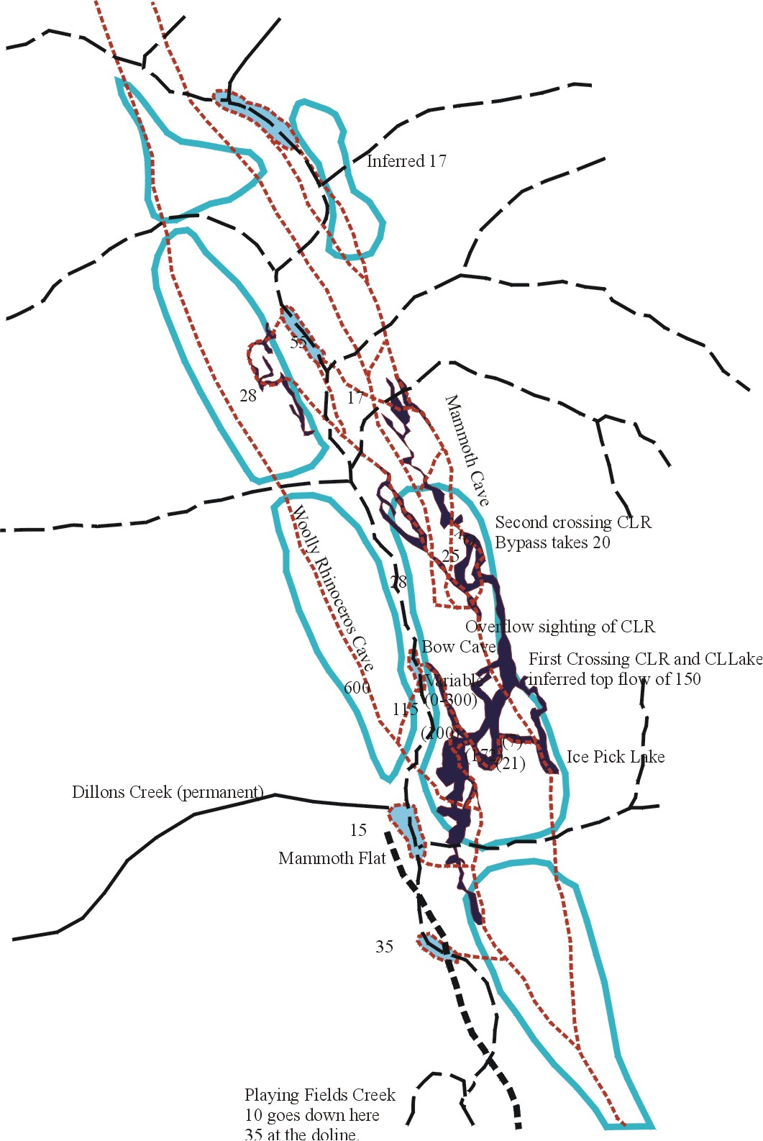.

Criteria on selecting a cave for commercial wild adventure tours
Report on Workshop held at ASF Conference "A Cave Odyssey 2001"
by Nicholas White

This was a well-attended workshop with quite a deal of lively discussion. There was no formal structure and no prepared papers presented. The discussions can be grouped under the following headings.

Choice of Cave

Characteristics considered were variety, vulnerability, ease of access, ease of use as operator and rescue perspective. The concept of "Sacrificial Cave" was brought up without dwelling on the term.

Commercial Operators

It was obvious that there were a variety of opinions regarding the competence of operators. Some consideration was given to the range of operators and whether their objectives were to service education groups, children or clients seeking adventure. There was a questioning of the conservation ethics of some operators. Considerable concerns were expressed about the used of caves for corporate bonding and team building uses. Concerns were expressed about the leadership qualities of operators and their employees.

Cave Managers

Cave managers have responsibility for ensuring Commercial Operators (including their own operations) are conducted responsibly with respect to clients and with respect to the karst resource under their management.

There were a lot of unknowns and perceptions that some managers were ruled by commercial motive. It was unclear which managers had satisfactory policies within Management Plans or Department Procedures governing the licensing of operators. It was not known which managers required operators to adhere to the ASF Codes of Conservation and Minimal Impact Caving (or similar). Insurance and liability questions were also raised in this discussion.

There was a lot of concern expressed about the criteria used to judge the leadership skills of operators.

Some of the concerns expressed problems (real or perceived) of competition with recreational cavers.

Conclusions

This workshop obviously touched many nerves. There was an inadequate information base on the extent of commercial operations and its affect on caves. ASF does not have formulated policy about commercial adventure cave operations. Anecdotal information was that there were concerns about such operations across the country.

The group was unanimous in expressing the need to be active in discussions with managers and commercial operators towards reaching a fuller understanding of adventure cave touring in Australia. It was suggested organising a Workshop on the subject to initiate the process.

Project Report for MSc.
Cave Aragonites of NSW
Jill Rowling
November 2000

Abstract:

A Part-Time MSc. Project at the University of Sydney, Geosciences Department. Supervisors: Tom Hubble and Dr Armstrong Osborne.
The aims of this project are to investigate caves reported to contain aragonite; verify that the material either is or is not aragonite; analyse the substrate on which the aragonite is depositing; and to determine what factors lead to the deposition of aragonite in NSW caves.
There is surprisingly little scientific literature regarding its occurrence in NSW caves.
There are a number of chemical and physical factors which affect the stability of aragonite in the cave environment. Aragonite is unstable in the freshwater environment, so deposition of aragonite in the spelean environment is unexpected, however it has been reported from a number of NSW cave areas.
Aragonite can deposit at the expense of calcite when a calcite inhibitor is present.
The methodology being used to investigate aragonite involves a literature search; visits to cave areas and selection of suitable field sites; obtaining samples at field study sites; analysis of samples; and determining what factors lead to the deposition of aragonite in NSW caves.
The project was started in July 1999. This presentation was originally given as a progress report to the Geosciences Dept at the University of Sydney on Friday 1st December 2000.

- Project Aims
The aims of this project are to:
- Investigate caves reported to contain aragonite
- Verify that the material either is or is not aragonite
- Analyse the substrate on which the aragonite is depositing
- Determine what factors lead to the deposition of aragonite in NSW caves.
2. What is Aragonite?

Aragonite is a polymorph of calcium carbonate, CaCO₃. It was named after the province of Aragon, Spain, where it occurs as pseudo-hexagonal twins.
Calcite is the more common polymorph encountered in the environment. Aragonite is classified in the orthorhombic crystal system whereas calcite is variously classified as belonging to the in the triclinic (Glazer, 1987), hexagonal/trigonal (Berry, Mason, Dietrich, 1983) or rhombohedral (Hurlbut, 1970) crystal systems.
Other polymorphs of CaCO₃ include the unstable vaterite (hexagonal) which occurs in gastropods and carbide dumps, as well as the high temperature and pressure Calcite-IV and Calcite-V which are not stable in near-surface environments.
Aragonite is harder and more dense than calcite, and has a characteristic acicular habit. It has two cleavage angles whereas calcite has the familiar three perfect cleavage angles.
Aragonite is mostly encountered in the marine environment, often the product of biological chemical activity such as the development of an organism's shell. When the organism dies, shell aragonite will in time revert to calcite in the near surface environment in the presence of fresh water. Outside of biological influences, the deposition of aragonite is generally considered the product of high pressure and / or high temperature on calcite, or chemical influence.
Given its instability in the freshwater environment, deposition of aragonite in the spelean environment is unexpected. In the spelean environment, calcite deposits are frequently coloured by humic acids whereas aragonite tends to be either white or coloured by metal impurities such as copper.

3. Stability

Carlson (1983), p192 shows a pressure-temperature stability diagram for various polymorphs of CaCO₃ however the scales are from 0 to 1200 C temperature and 0 to 40 kbar pressure.
The spelean environment is about 15 C and about 1 bar pressure only, which is in the stability range for calcite. At these temperatures and pressures, aragonite is unstable. Aragonite is stable above about 3 kbar pressure which does not occur in the surface environment.
Based on temperature and pressure alone, in the cave environment one would expect calcite to be the only form deposited yet aragonite does occur therefore there must be another factors other than temperature or pressure for aragonite to occur in caves.

4. Reasons for doing this project

Aragonite is chemically unstable in the normal cave environment, however it has been reported from a number of NSW cave areas as shown in Table 1.
Table 1: Caves reported to have Aragonite
Cave Area | Caves with aragonite
Jenolan | 13
Wombeyan | 7
Cliefden | 3
Wee Jasper | 3
Bungonia | 2
Yarrangobilly | 2
Colong | 1
Jaunter | 1
Walli | 1
Wyanbene | 1

There is surprisingly little scientific literature regarding its occurence in NSW caves.
There are a number of chemical and physical factors which affect the stability of aragonite in the cave environment. These include:
- humidity
- air movement and
- presence of calcite inhibitors (Morse, 1983) such as:
  - magnesium
  - manganese
  - sulphate
  - phosphate
Aragonite can deposit at the expense of calcite when a calcite inhibitor is present.
Other workers have mentioned strontium, temperature, rate of deposition or CO₂ concentration as being influential in the deposition of aragonite however the views are sometimes contradictory.
In limestone areas where aragonite has been reported, bulk sampling of the bedrock by the Mines Dept. has often shown high purity of limestone with insignificant concentrations of impurities.
The best aragonite seems to occur in those same limestone deposits in small areas featuring what is usually termed by cavers and cave guides as ``rotten rock''. Some of these sites at Jenolan have been described by Dr Osborne (Osborne, 1993 and 1999).
Identifying aragonite sites and their substrates may help to determine reasons for the aragonite occurence in these areas. It may also help to determine some of the geological events that have happened since the limestone was originally deposited.

5. Project Methodology

The methodology being used to investigate aragonite is as follows:
- Literature search
- Visit cave areas and select suitable field sites
- Obtain samples at field study sites
- Analyse samples
- Determine what factors lead to the deposition of aragonite in NSW caves.

6. Current Status of the Project

6.1 Literature Search
A literature search was started last year for all references to cave aragonite in NSW as well as aragonite in general, summarised in Table 2.

Table 2: References to aragonite in publications
Type of Publication | Refs
NSW Cavers' trip reports | 4
Other publications on NSW Caves | 15
Other spelean aragonite | 9
Aragonite in general | 27
Total references | 55

Additionally, there are a number of unpublished accounts by cavers together with verbal reports and photographs showing what appears to be aragonite in NSW caves.
One of the most useful ``Other references'' was by Morse on the kinetics of aragonite precipitation. Morse lists a number of anions and cations which can assist in the deposition of aragonite by inhibiting the precipitation of calcite.
It has been encouraging to see evidence of some of these materials in caves where aragonite occurs, in particular magnesium, manganese, sulphate and phosphate.

6.2 Field Site Visits
I obtained permission from each of the site owners before visiting a site or sampling at a site.
The type of application varies from land owner to land owner, with some having no formal arrangements and others requiring specific forms to be filled in before permission is granted for a visit.
Usually a separate application is required for each visit.
Permission to sample is in some cases more difficult than others; it depends on the site owner. This is summarised in Table 3.

Table 3: Site Permits
Controlling | Visiting | Sampling
Authority | Permit | Permit
JCRT | Yes | Yes
SSS | Yes | Yes
OSS | Yes* | Not yet
TK | Yes* | Not yet
NSW NPWS | Yes* | Not yet

* Had been visited prior to this study being undertaken
JCRT Jenolan Caves Reserve Trust, controls access to Jenolan, Wombeyan, Abercrombie
and Borenore Caves.
SSS Sydney Speleological Society, controls access to Walli Caves through an
arrangement with the property owner.
OSS Orange Speleological Society, controls access to Cliefden Caves through an
arrangement with the property owner.
TK The Property owner, Tarakuanna. This property has changed ownership. Caves are
part of the Jaunter limestone deposit.

6.3 Field Sites
The following field sites were visited over the period November 1999 to November 2000:
- Jenolan Caves:
  - Contact Cave
  - Wiburds Lake Cave
  - Ribbon Cave (joint trip with Australian Museum: David Colchester, Ross Pogson and Armstrong Osborne)
  - Mammoth Cave
- Wombeyan Caves:
  - Wollondilly Cave
  - Guineacor Cave
  - Cow Pit
- Walli Caves:
  - Piano Cave (after C. S. Wilkinson, NSW Government Geologist in 1876) (Wilkinson, 1892).
- Wellington Caves:
  - Phosphate Mine

6.4 Samples
Rather than duplicating work with relatively scarce material, I am trying to collaborate with other workers who have already studied cave minerals, as well as obtaining my own original samples where such work has not already been done.
For example, at Jenolan Caves, the Australian Museum has been sampling in the tourist caves and at Contact Cave. The analyses show that the material sampled is aragonite with magnesium carbonate (as huntite).
I have some very small samples of ``aragonite'' from most of the caves visited, and also samples of some of the matrix in which the material was embedded.
Samples of speleothem need only be very small, eg pin head size. Samples of bedrock however need to be larger for thin section preparation, and care must be taken when taking the sample so as not to disturb or damage an important site.

6.5 Analysis
Preliminary optical work has shown that some of the matrix is very interesting and nothing like the ``normal'' limestone bedrock. The material is considerably altered. Some samples appear to be dolomitic and other samples look more like a weathered low grade ore body.
Examining some of the ``aragonite'' with optical microscopy shows that the material has the same form as that expected for aragonite, however full analysis will require X-ray techniques.
I am intending to undertake this work early next year (ie 2001).

6.6 Mapping
Cave maps are an essential tool for documenting sample locations and the cave's mineral deposits. In some cases, the caves have already been mapped but in other cases, original maps need to be prepared.
I have prepared maps of the following caves:
- Jenolan Caves: Contact Cave
- Wombeyan Caves: Cow Pit, parts of Wollondilly Cave.
Maps are drawn to 1:100 scale using standard Australian Speleological Federation symbols. Both plan and elevation are given, and sample points are being indicated on the maps. Geological features will be indicated as well (in prep.; some sketches were shown).

6.7 Problems Encountered
Some of the problems encountered during this study have included:

- Needle form calcite can sometimes look like aragonite so I need to await XRD analysis before deciding what it is!
- Not being able to fit into some parts of caves said to contain aragonite!
- Some speleothems are a mixture of calcite and aragonite.
- Some of the bedrock material is surprisingly hard. Special techniques may be required in some cases to get samples without making an obvious mark. This is important where the site is part of a tourist cave display or it is an important conservation site.
- Sometimes caving collegues fall asleep, get bored, cold or run away!

7. Future Plans
My plans for the future of this project include:
- Concentrate on the following caves as case studies:
  - Wombeyan: Sigma Cave
  - Bungonia: Flying Fortress Cave
  - Jenolan Caves: Wiburds Lake Cave and Contact Cave
  - Walli Caves: Piano Cave
- Obtain cave maps or survey and draw them as required
- Obtain samples of aragonite, matrix and bedrock
- Analyse precipitating fluids associated with aragonite deposits.
- Attend course in X-ray analysis, SEM and sample preparation
- Analyse samples for aragonite and trace elements
- Measure temperature, CO₂ and humidity in the caves to see if there is any correlation with the presence of aragonite.
- Study thin sections of bedrock and matrix (in prep.)
- Carbon - Oxygen isotope analysis will also need to be done.
- It has been suggested that I should also look for possible evidence of microbial activity associated with aragonite.

8. References

Berry, L.G., Mason, B. & Dietrich R.V. (1983). ``Mineralogy: Concepts, Descriptions,
Determinations'' Freeman.
Carlson, W.D. ``The Polymorphs of CaCO₃ and the Aragonite - Calcite Transformation'' In:
Richard J. Reeder (Ed.) ``Carbonates: Mineralogy and Chemistry'' Mineralogical Society
of America 191-226.
Glazer, A.M. (1987). ``The Structures of Crystals''. Hilger.
Hurlbut, C.S. Jr. (1970). ``Minerals and Man'' Random House.
Morse, J.W. (1983). ``The Kinetics of Calcium Carbonate Dissolution and Precipitation'' In:
Richard J. Reeder (Ed.) ``Carbonates: Mineralogy and Chemistry'' Mineralogical Society
of America 227-264.
Osborne, R.A.L. (1993). ``Geological Note: Cave formation by exhumation of Palaeozoic
palaeokarst deposits at Jenolan Caves, New South Wales'' Aust. J of Earth Sc. Vol 40.
591-593.
Osborne, R.A.L. (1999). ``The Origin of Jenolan Caves: Elements of a new synthesis and
framework chronology'' Proc. Linn. Soc, NSW No 121 1-27.
Wilkinson, C.S. (1892). ``Description of the Belubula Caves, Parish of Malongulli, Co. Bathurst''
Records of the Geological Survey of NSW, Dept Mines, Sydney, Vol III Part 1. 1-5,
plates I-III.

9. Contact details
Address for Correspondence: Jill Rowling, 2 Derribong Place, Thornleigh NSW 2120 Australia
work email: rowling@ali.com.au
home email: jillr@speleonics.com.au

Cataloguing Helictites
and other capillary-controlled speleothems
Jill Rowling
December 2000

Abstract:
In the 2nd Edition of Hill & Forti's book, "Cave Minerals of the World", helictites are described with three subtypes. Other capillary controlled speleothems described by Hill and Forti are Cave Shields and Welts.
This article suggests the addition of some other capillary controlled speleothems to the list, then attempts to sub-divide the speleothem type "helictite" into further sub-types.
The reason why is because there are several sub-types which can be recognised around the world as being of the same form, however there is no specific name given to them.
Possibly this consistency of form is due to a common chemical or biological influence, and cataloguing the forms is the first step in understanding what causes them.
Forms include ribbon helictites, saws, rods, butterflies and "hands". Influences include multiple canals, gravitation, possible chemical changes, and crystal twinning. Materials include calcite needle-form calcite and aragonite. Vaterite is touched-on however it generally occurs in caves as the result of human intervention (pollution).
Finally this article suggests that a better classification scheme could be done using a database rather than attempting to force a hierarchy onto disparate objects.

1. Project Aims
The short term aims of this project are to attempt to describe the varieties of helictites and related speleothem forms. The long term aims of this project are to:
- Determine the internal structure of each form
- Determine what the object is made of
- Determine what factors lead to the deposition of this form
- Develop a catalogue of helictites and related forms

2. What is a Helictite?
Helictites are a type of speleothem (cave decoration, spelean chemical sedimentary deposit) which are found in the limestone caves of most countries of the world.
Although usually described by many tourist cave guides as ``mysterious'' and of ``unknown origin'', the basic structure of helictites has been known for a long time, the earliest detailed description being by Olaus Worm in 1665 (Shaw, 1992).
A typical calcite helictite is a twisted, long cylindrical structure with a fine central capillary of about 0.2 - 0.35 mm diameter. Side micro-canals (``canalicules'') result in a somewhat porous structure. Typically the helictite has radial symmetry.
A discussion of subaqueous helictites from Lechuguilla Cave, New Mexico by Davis, Palmer & Palmer (1991) showed a sectioned sample with its radial crystal growth and central canal.

3. What is a Related Form?
One of the key features of helictites is their capillary tube which can be straight or branched. Other speleothems have capillaries, too. Examples:
- Cave shields (capillary sheet)
- welts (capillary ring)
- anthodites (fibrous channels on surface)
Possibly popcorn and coralloids could be classified as a related form because of the effect of the surface capillarity.

4. Some additional forms of capillary-controlled speleothems
There are some additional speleothem types which appear to be capillary-controlled.
In Lucas Cave (Jenolan Caves, NSW) and Fig Tree Cave (Wombeyan Caves, NSW) there are hard white hemispherical deposits on the roof and walls of areas which have high air flow. They appear to be made of calcite. They deposit on bedrock, at joint intersections. Possibly they are made in the same way as are masses of helictites, ie by seepage along capillary channels, but due to the high air flow, precipitation of calcite occurs before the structure has a chance to develop a tube. Further investigation is required.
In Chifley Cave, Jenolan, there are some cauliflower-shaped deposits on the floor and walls. They are made of a mixture of calcite (including lublnite), silicates and phosphates (like a soil) however it could be argued that the form, as such, is the result of capillary action in a porous medium. It could also be argued that they form like cave caps (Hill & Forti, 1997) where new material is being deposited at the base of the deposit, locally raising the surface. More study needs to be done on these before deciding whether they are a capillary structure or not.

5. Present Classification System for Helictites
Hill & Forti (1997) have classified helictites as follows:
Type
: Helictites
Sub-types
: Subaerial, subaqueous
Varieties
: filiform, beaded, vermiform, antler
Heligmites are classified as simply helictites that grow upward from the cave floor. Helictites are further classified into varieties, again based on form (morphology) which can be identified in the field, as seen in Table 1.

6. Problems with the existing classification system
Just as there have been difficulties with cave classification schemes, there are difficulties with classifying speleothems, especially oddball things like helictites.
- The ``variety'' classification gives no hint as to structure.
- Structural classifications are only in their infancy
- Helictites deposited from different materials may have different forms
- There are additional ``varieties'' yet to be classified.
Table 1: Hill & Forti classification of helictite varieties
Variety | Further classifications
filiform | thread
beaded | unbranched
 | branched
 | sea anemone
antler | antlers
 | rod helictites
vermiform | worms
 | corkscrew
 | jag at right angles
 | combined with straws
 | butterfly
 | bell
 | tomahawk
 | pigtail
 | hook
 | tangled masses
 | unicorn horn

7. Some additional forms of helictite
In NSW caves and elsewhere I have noticed some helictite forms which aren't well described in the latest edition of Hill & Forti.
The same forms occur in several caves both in Australia and elsewhere in the world.
They have consistency of form: that is, if one looks for a particular shape of helictite (eg butterfly) one can find examples in other caves around the world. Often where they do occur, all the helictites in the one area are of the same form. Presumably the same set of influences occurs at each site for a given form.
Table 2: Some descriptive names
Name | Location | Comment
Saws | Orient Cave, Jenolan | Straight, gravity effect
Rods | Ribbon & Baal, Jenolan | Long, maybe fibrous
Butterflies, hands | Orient Cave, Jenolan | Twinning effect
Upturned helictites | Tantanoola Cave, SA | Gravity effect
``Peripatus'' | Sigma Cave Wombeyan | Fractal appearance
Ribbon Helictite | Jubilee Cave, Jenolan | Needle form calcite
Intermediate forms | Cliefden Main Cave | Curved, flattened

Unfortunately, I have no way of telling (without a picture) whether the forms described above are actually the same as what other people have described. For example, are the ``rod'' and ``butterfly'' forms in Table 2 the same as those of the same name in Table 1? Is the "butterfly" form in Table 1 the twin version of the ``tomahawk'' form?
The helictite form taken by vaterite in carbide dumps is also unusual; it is an inverted horn shape (carbidimites) and is unstable: the form changes over months. Carbidimites are discussed in Hill & Forti (but not in the section on helictite forms).
Another form, again in Hill & Forti is the pseudo-helictite as photographed by V. Maltsev. This is a concentric tube of calcite over an aragonite core, with dolomite between the two: a triple layered speleothem.
Names may help to describe helictite forms. Some are described below. A better way of classifying these forms is discussed later.

7.1 Saw Helictites

Saw helictites are generally straight (see Figure 1). The lower edge appears to have a row of prototype straw stalactites along it. The cross section shows the helictite has a central canal and is symmetrical. Its development is influenced by gravity. Saw helictites appear to protrude from the wall at fixed angles, typically about 35 with respect to the wall. They have a central canal and appear to have minor side canals. If a laser pointer is used to light up the tip of one of the ``stalactites'', the light also appears to be conducted along a curving, cone-shaped portion of the main part of the helictite.
r70mm 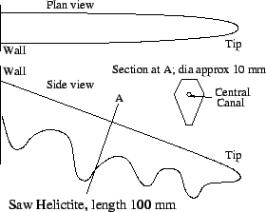
Figure 1: Saw Helictite

Some saw helictites appear to be composed of a series of half-butterfly helictites (see Figure 3) with well-developed ``wings'' and ``tails'' (ie the stalactites). More work needs to be done on saw helictites.

7.2 Rod Helictites

Rod Helictites (see Figure 2) are generally straight, similar to saw helictites but without the saw edge. They are often found protruding upwards from walls or columns, making an angle of about 30 or 60 degrees to the vertical. Their cross section is almost the inverse of that of the Saw helictite. They appear to be made of en-echelon stacks of calcite crystals, although this could be just the surface coatings. Rod helictites can be quite large, with a total length of about 1 metre and a diameter of about 20 mm. They can be seen in the Temple of Baal, the Orient Cave and the Ribbon Cave, Jenolan Caves, NSW. They are often associated
r70mm 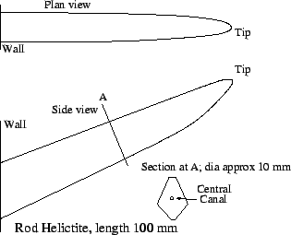
Figure 2: Rod Helictite
with deposits of aragonite and hydromagnesite, however they are also

sometimes found partially engulfed in flowstone. Although rod helictites are usually straight, both bent and branched ones occur. This may well be the ``rod'' variety described in Hill & Forti.

7.3 Butterfly Helictites

Butterfly shapes can occur either singly (imagine a resting butterfly with its wings folded together) (see Figure 3) or twinned to form a pair of open wing shapes. The single wing shape may be the "tomahawk" as mentioned in Hill & Forti. Close inspection of this type of helictite shows that it appears to be made of a number of segments, each optically continuous but with optical discontinuities at the segment boundaries. This can be seen using a laser pointer. The segments appear to be recrystallised. They appear to have a number of micro-channels rather than the usual single canal that most helictites have. Possibly what happens is the micro channels may fork, so the speleothem develops a broad wedge shape. Growth seems to occur predominately in one plane. It is clearly influenced by gravity (the stalactitic deposit forming the butterfly
``tail''). The open butterfly shape appears
r70mm 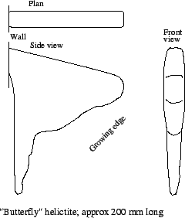
Figure 3: Butterfly Helictite

to be due to crystal twinning,where each half shares a common attachment point to the wall, and whatever influences one side will influence the other side. They occur in Orient Cave, Jenolan Caves, Wyanbene Cave, NSW, and numerous other caves around the world.

7.4 Hand or Shell Helictites
r78mm 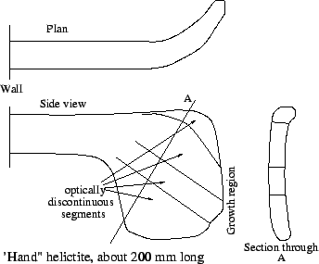
Figure 4: Hand Helictite

Similar to the Butterfly Helictites, Hand (or Shell) Helictites are planar structures. They generally lack the stalactitic ``tail'' that the Butterfly Helictites have. They also occur as twinned pairs. They are made of segments, as can be seen with a laser pointer. Hand helictites look like a pair of hands in mittens; there is a distinct ``wrist'' and the ``hand'' section is translucent. It can be curved. One hand helictite is show in Figure 4. They occur in Orient Cave, Jenolan.

7.5 Intermediate forms

Some other intermediate forms are like a ribbon helictite but with diagonal spikes (like aragonite) leading to a saw edge. These can get fairly large. They occur in between Orient Cave and Ribbon Cave, Jenolan Caves, NSW. Another intermediate form is like the saw helictite, but with a smaller zigzag edge. They curved regularly forming loops and occasionally a spiral, with a diameter of about 10 cm. This form is fairly common at Cliefden Caves, NSW, forming large clumps of similar helictites.

7.6 Ribbon Helictites

Ribbon Helictites are flattened helictites. They are generally fairly small, typically 5 mm wide, 1 mm thick and 20 mm long. The type locality is Jubilee Cave, Jenolan Caves NSW Australia. See Figure 5.
r85mm 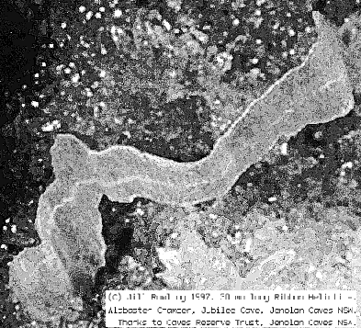
Figure 5: Ribbon Helictite
They appear to be made of calcite in the lublinite form, although individual crystallites appear to be an order of magnitude larger than those of lublinite. A detailed description of Ribbon Helictites is in Rowling (1998). Basically, they have a short stem made up of a twinned pair of crystallites with the central canal developed between the pair. Crystallites are made of pseudo-hexagonal columns of calcite in the lublinite form. At the end of the stem, the ribbon develops. This is a flattened structure made of twinned sets of crystallites, aligned with those of the stem. The central canal is usually visible in the centre of the ribbon as a thin white line. At Jenolan Caves, they are usually associated with ancient gravel beds which appear to have reacted with the limestone.

7.7 Heligmites
r55mm 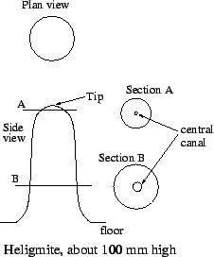
Figure 6: Heligmite

Heligmites are generally classified as helictites which simply develop on the ground rather than on a wall or roof. However there are some exceptions where the heligmite should be classified separately.
In this case, the heligmite is a fairly large structure resembling a stalagmite. They have a central canal. In large heligmites (say 30 cm tall and 5 cm diameter), the central canal can be about 5 mm diameter in the main part of the heligmite but microscopic at the tip.
In this type of heligmite, the central canal appears to be filled with a sticky, fine mud. Large examples can be seen at Tantanoola Cave, South Australia, where they have

developed in a dolomite cave. Lesser examples can be seen at Jenolan Caves. They can have side branches.
One of the Jenolan Caves heligmites (Dwyers Cave) appears to have dark material deposited along with the clear calcite; possibly this is manganese dioxide. The Tantanoola heligmites also seem to have this dark material.
One could argue that these large heligmites are actually geysermites, however the definition of geysermites in Hill & Forti specifies that geysermites have thin walled sides and a crater-like central hole whereas these heligmites have very thick sides and no apparent central hole at the tip, ie they are more like a normal helictite
In both these sites, the speleothems are developed in an area which does not have geysers or thermal springs. Swelling clay, however, may be a contibuting factor.

7.8 Upturned Helictites
r45mm 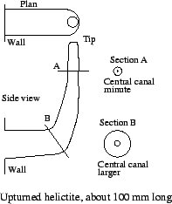
Figure 7: Upturned Helictite

Upturned helictites are usually vermiform helictites which initially develop with a horizontal orientation, then they develop in a vertical (upward) orientation. The horizontal development is usually only about 5 cm length, however the vertical development can be metres long.
Some of the best examples can be seen at Tantanoola Cave SA, where they can be seen attached to stalactites and columns; they resemble electrical wiring in some places. A smaller version can be seen in the Wollondily Cave, Wombeyan Caves, NSW, where they appear to be associate with magnesium deposits.
At the bend, the central canal appears to be enlarged. More work needs to be done on this type of helictite.
There is a similar form of upturned helictite which appears to be common in caves all round the world. This form however rarely reaches the size of the Tantanoola helictites and may either stop developing once a certain size is reached, or may become engulfed with flowstone.

7.9 More forms - subaqueous
After the ASF conference, I was alerted to some more new forms of helictite, this time underwater in Nurina Cave on the Nullarbor. Paul Boler (pers. comm.) has shown finger shaped heligmites, as well as a crested form and a conical form. Again, these are not one-off; where they occur there are a lot of similar ones nearby. They appear to be actively depositing.
In McCavity, Limekiln Cave, Wellington Caves, NSW the divers have found large helictites underwater however these appear to have been deposited originally in air and the cave has subsequently filled with water. The helictites in this case have a clear crystalline core (possibly aragonite?) and a thick dark coating (possibly a mixture of calcite and manganese dioxide). They may be still active.
I have seen what appears to be a subaqueous helictite under a baldacchino canopy in Croeseus Cave, Tasmania. This was not an unusual form, though, and would be normally classified as tthe Vermiform variety.
Possibly there are more of these around if we look for them.

7.10 Peripatus Helictites
r83mm 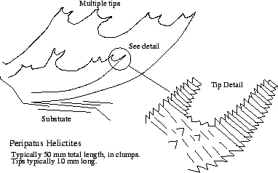
Figure 8: Peripatus Helictites

Peripatus helictites were discovered in Sigma Cave, Wombeyan Caves, NSW during a cave survey. At first, they were thought to be simply corroded helictites. After developing the photographs, it was apparent that they were yet another undescribed form.
They have a very rough surface, composed of small crystal terminations. This makes them difficult to photograph as they tend to absorb light.
They appear to form horn shapes, where each horn forms part of a larger horn (see Figure 8). The angle that the horn axes make with each other is similar to the angle at which aragonite tends to develop (split).
They occur on flowstone (as shown) and in a stalactitic form, associated with a white deposit (possibly hydromagnesite).
The general form is fractal in nature, in that the closer you look, you still see similar shapes (paired horns).
The name "Peripatus" is after a fancied resemblance of the fine structure to the rough skin of the velvet worm, Peripatus.

8. Proposed Classification System for Helictites
The system being proposed should take into account the various factors involved in the development of helictites and other capillary-controlled speleothems.
Unfortunately for the general caving community, it does not classify helictites into neat ``pigeonholes''.
One of the interesting things about helictites is that there are indeed consistent types. They are not just random aggregates. Ribbon helictites, for instance, are fairly rare throughout the world but locally common where they do occur.
Helictites of a particular form often occur in groups of all one sort, inferring that there is something that has caused the helictites to take on the particular form.
Here are some of the factors that should be taken into account:

8.1 Gravitational effects
Gravity may affect the alignment of the helictite. It may affect the long section or the cross section.
- Is the helictite aligned with respect to gravity? This may occur if the helictite has a large central canal where capillarity is balanced by gravitational force (eg drips or density of liquid / mud). In the case of subaqueous helictites, there may be a difference in the density of the liquid within the helictite compared to the water in which it has developed.
- Does it develop at a specific angle with respect to gravity? This can occur if calcite polysynthetic twinning is involved. This is a feature of calcite whereby sufficient pressure along cleavage planes causes the calcite to move along the planes in a regular way (like a deck of cards) without breaking.
- Is its cross section aligned at a specific angle with respect to gravity? If a cross-section is meaningful, one may notice that it is always aligned one way. Again, this infers that there is a density effect or water may gather at one end of the helictite.
Examples include rods, saws and hands in Orient Cave, Jenolan; heligmites; stegamites; helictites in Tantanoola Cave (SA).

8.2 Crystal twinning effects
- Does the helictite display any symmetry either by itself or as an aggregate? Ribbon helictites are highly symmetrical. They have four fold symmetry.
- Are there any identifiable repeat patterns in the form? For example, with some branched helictites, one notices that every branch occurs at a certain angle and at every branch there is only on fork.
- Does the form appear to be fractal in nature? That is, is the helictite made up of miniatures of the same shape? Does it look as though it is made of repeat patterns?

Examples: ``Peripatus'' helictites in Sigma Cave (Wombeyan, NSW); ribbon helictites; ``butterflies''.

8.3 Environmental effects
- Does air or water flow appear to have influenced the helictite's growth?
- Carbon dioxide levels in air, water and substrate?
- Humidity in both air and substrate?
- Temperature of air, water and substrate?
- Presence of water (subaqueous or subaerial helictites)?
- Groundwater (rainfall), climatic changes?

8.4 Trace element effects
- Presence of metals such as magnesium, iron, copper, lead in helictite or in water? Ribbon helictites, for example, contain about 0.5% Fe. This does not colour them (they are clear) however it may influence the crystal growth by causing regular crystal lattice defects.
- Presence of sulphate and phosphate in helictite or in water

8.5 Crystal system effects
Is the helictite composed of all one type of material or are there influences from different minerals and their polymorphs?
- CaCO₃ polymorphs: Calcite / aragonite / vaterite
- Halides and sulphates
- Crystal and crystallite alignment with respect to helictite development
- Crystal size ranges
Example: Vaterite helictites associated with carbide dumps; beaded helictites.

8.6 Biological effects
- Presence of calcite as needle-form calcite (lublinite)
- Association with sulfuretums (sulphur cycles)

8.7 Substrate effects
The porosity of the substrate may affect the development of helictites.
- Gravel substrate
- Clay substrates
- Ochre substrates

8.8 Canal effects
- Single central canal
- Multiple central canals
- Side-branching canals (canalicules)
- Surface capillary channels
- Shape of canal: Circular, flat, U-channel, hexagonal, spherical etc?
- Size of canals
For example, most vermiform helictites have circular central canals whereas the capillary channel in a cave shield is a flat sheet. Welts and ``turnips'' have spherical hollows. Some of the helictites described in this article have branching canals.

8.9 Activity
Is the helictite active or ``dead''?
- If ``dead'', when was it formed and under what conditions (U-Th dating, etc)?
- If ``live'', what is its growth rate?

8.10 Development habits
Additional information may be useful in describing the helictite.
- Presence of active / inactive drip points at regular or irregular intervals
- Straight habit (like a rod)?
- Curved habit, spiral habit, radius of curvature?
- Shape of cross section(s)
- Overall length and widths
- Fracture habit
- Colour
- Surface texture and pattern
- Forking habit and angles of forks
- Bending habit and angles of bends

9. Summary
There is really no way we could give individual names to each of the combinations and permutations of influences as listed above.
Although the classification scheme by Hill and Forti serves well for the general caver, a more comprehensive classification scheme is needed if we want to explain what causes the development of helictites.
Possibly this could be addressed by developing a catalogue of helictite types rather like a smaller version of ``Cave Minerals of the World''.
This would be huge undertaking however it could be started as a set of tables, at least defining those influences relevant to helictites and lead to a useful, publically accessable database of helictite forms.
One of the nicer features of databases is the information is not stored in a hierarchy, so one is not forced into classifying things first. Rather, that becomes the responsibility of the application rather than the database itself.
One could query the database for all helictite forms which were found underwater. Or all helictite forms containing aragonite. Or all helictite forms at Jenolan Caves. Or those that had single central canals. Or whatever.
It also makes it possible to visualise the helictite without having a photograph of it. Possibly the shape could be described in terms of parameters to an equation, which could then be displayed by an application.
If and when an exact explanation can be found for the development of a particular helictite form, that can be added to the database (or at least a reference to it).
The concept can also be used for conservation. For example, if it is found that a particular helictite only occurs with certain bacterial colonies, then it would be inadvisable to clean up a tourist cave containing such helictites using an antibacterial cleaning agent.
Also if a particular helictite form is known to have small water reservoirs as part of its make-up, then it would not be advisable for a tourist cave operator to put strong, high powered lights on the speleothem otherwise the water can boil and fracture the helictites (cave photographers take note!).

10. References
Davis, D.G., Palmer, M.V. & Palmer, A.N. (1991) ``Extraordinary Subaqueous Speleothems in
Lechuguilla Cave, New Mexico.'' National Speleological Society Bulletin 52: 70-86.
Hill, C.A., and Forti, P. (1997) ``Cave Minerals of the World.'' National Speleological Society,
Huntsville. 2nd Ed.
Rowling, J. (1998) ``Ribbon Helictites: A New Category'' Helictite 36(1), 2-10.
Shaw, T.R. (1992) ``History of Cave Science'' Sydney Speleological Society. 2nd Ed.

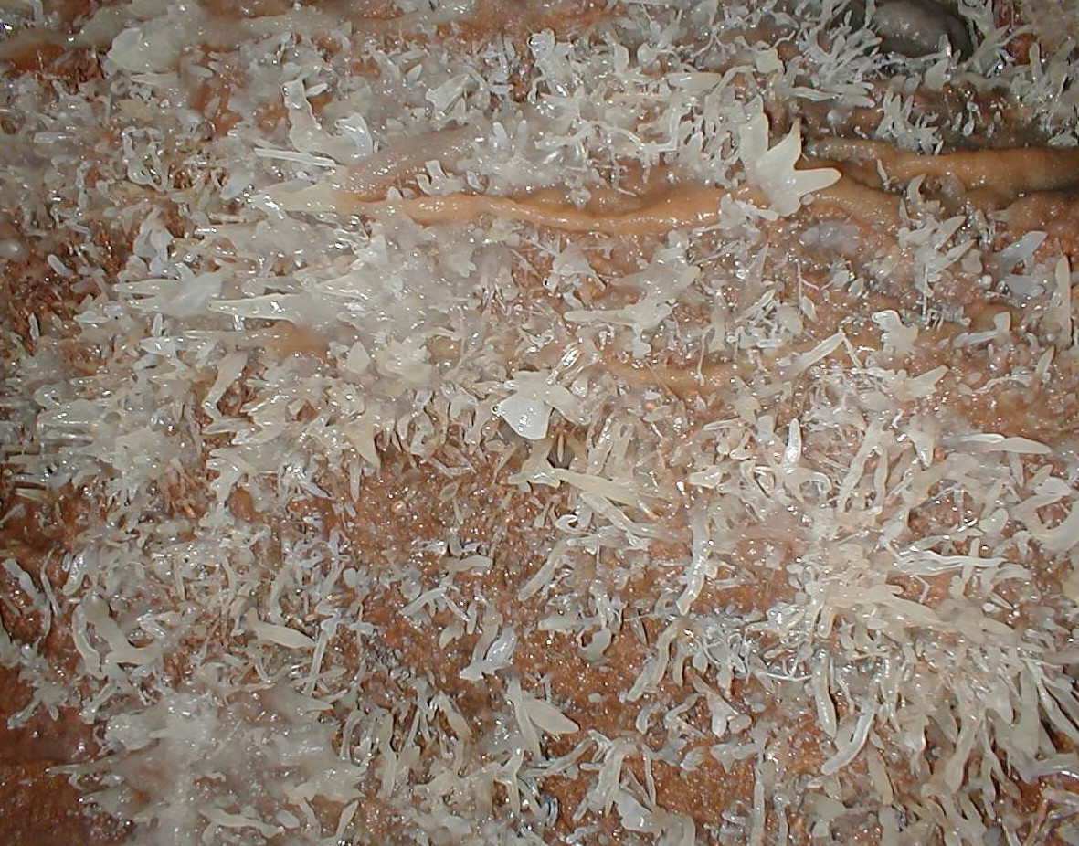
Arthur Clarke

Helictites in Orient Cave, at Jenolan

